**Introduction to Object Oriented ECMAScript 6&JavaScript**

Lab Book

Document Revision History

|  |  |  |  |
| --- | --- | --- | --- |
| Date | Revision No. | Author | **Summary of Changes** |
| March 2016 | 1.2 | Rahul Vikash | Created new lab book as per revised course contents |
|  |  |  |  |
|  |  |  |  |
|  |  |  |  |

Table of Contents

*Getting Started..……..…………………………………………………………………………… 4*

Overview 4

*Setup Checklist for* Introduction to Object Oriented 4

Instructions 4

Learning More 4

*Lab 1. Object Oriented JavaScript 5*

*Lab 2.* Prototypal *7*

*Lab 3. JSON 7*

*Lab 4. EcmaScript6 7*

*Appendices………………………………………………………………………………………… 11*

## Appendix A: Table of Figures ………………………………………………………… 11

Getting Started

## Overview

This lab book is a guided tour for learning Introduction to Object Orientedversion and above. It comprises ‘To Do’ assignments. Follow the steps provided to work out the ‘To Do’ assignments given.

## Setup Checklist for Object Oriented JavaScript

Here’s what is expected on your machine for the lab in order to work.

Minimum System Requirements

* Intel Pentium 90 or higher (P166 recommended)
* Microsoft Windows XP, Windows 7 or Windows 8
* Memory: 2GB of RAM (1GB or more recommended)
* Google Chrome 36.0 or Mozilla Firefox 31.0 or Internet Explorer 10 or above

Please ensure that the following is done:

* A text editor like Notepad or Notepad++ or Eclipse Luna is installed.

## Instructions

* Create a directory by your name in drive <drive>. In this directory, create a subdirectory JavaScript. For each lab exercise create a directory as lab <lab number>.

1. Object Oriented JavaScript

|  |  |
| --- | --- |
| Goals | * Working on Object Oriented JavaScript-work on Objects & function |
| Time | 20 minutes |
|  |  |

1. Create function Product ,as shown in below diagram

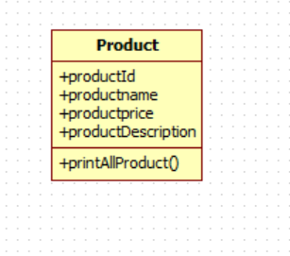

1. Take data from user & put in the product .
2. Take number of product data by using console & print all data on console

1. Prototypal

|  |  |
| --- | --- |
| Goals | * Working on _proto,Prototype |
| Time | 20 minutes |

2.1 Extend lab assignment one & as per below mentioned diagram

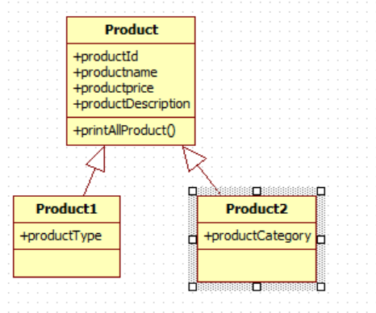

Take data from console & Print all detail of Product 1 & Product 2 such as id, name, price, description .Also type & category for both product

Lab 3: JSON

|  |  |
| --- | --- |
| Goals | * Working on JSON |
| Time | 1. minutes |

1. Create function Product ,as shown in below diagram



1. Serializes a JavaScript value to JSON text.
2. De-serializes JSON text to produce a JavaScript value

**Lab 4: EcmaScript6**

|  |  |
| --- | --- |
| Goals | * Working on JavaScript ECMAScript 6 |
| Time | 1. minutes |

4.1 Extend lab assignment 2.1 do it by using ECMAScript 6



Take data from console & Print all detail of Product 1 & Product 2 such as id, name, price, description .Also type & category for both product

4.2 Create class using concept of EMCAScript6 as per below mentioned diagram

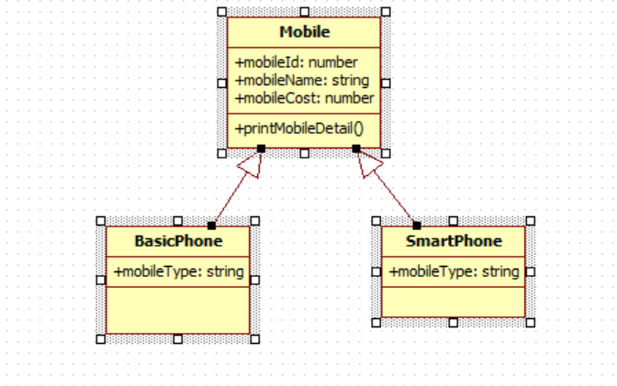

All 3 classes are in separate file. We have to add mobile details such as id, name, cost & type from different typescript file & print data in console

1. Get Data from array

## Appendix A: Table of Figures

Figure 1 5

Figure 2 5

Figure 3 6

Figure 4 6

Figure 5 7

Figure 6 8

Figure 7 8

Figure 8 8

Figure 9 9

Figure 10 10

Figure 11 10

------------Array Lab assignment-----------------

//create number array with some initial entries[90,50,10,40]

//create menu[1:add-2:delete-3:update-4:search – 5:fetchAll- 6:exit

Enter chioice:1/2/3/4/5/6

1:Add

Enter number to be added

User enter:78

2:Delete

Ebnter number to delet

50

1:addemp 2